MACH4METAL

metalworking machinery
Transito 21,
6909 DA BABBERICH, Netherlands
Tel. + 31 (0)316 – 247123
Fax. + 31 (0)316 - 247956
info@mach4metal.com
www.mach4metal.com

Bank No : 66.52.13.883
IBAN : NL33 INGB 0665 2138 83
BIC : INGBNL2A

TOS HULIN SKI 12 CNC
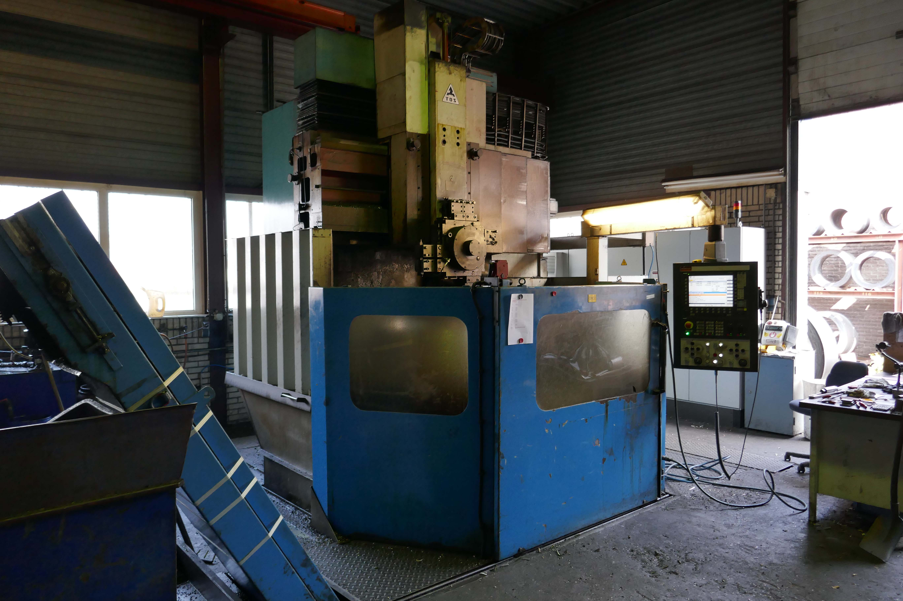
- Make : TOS HULIN
- Typ : SKI 12 CNC
- Age : 2014 Retrofitted
- Serial No : 10894

- Table Ø : 1.250
- Max. swing : 1.500
- Max. height : 1.245
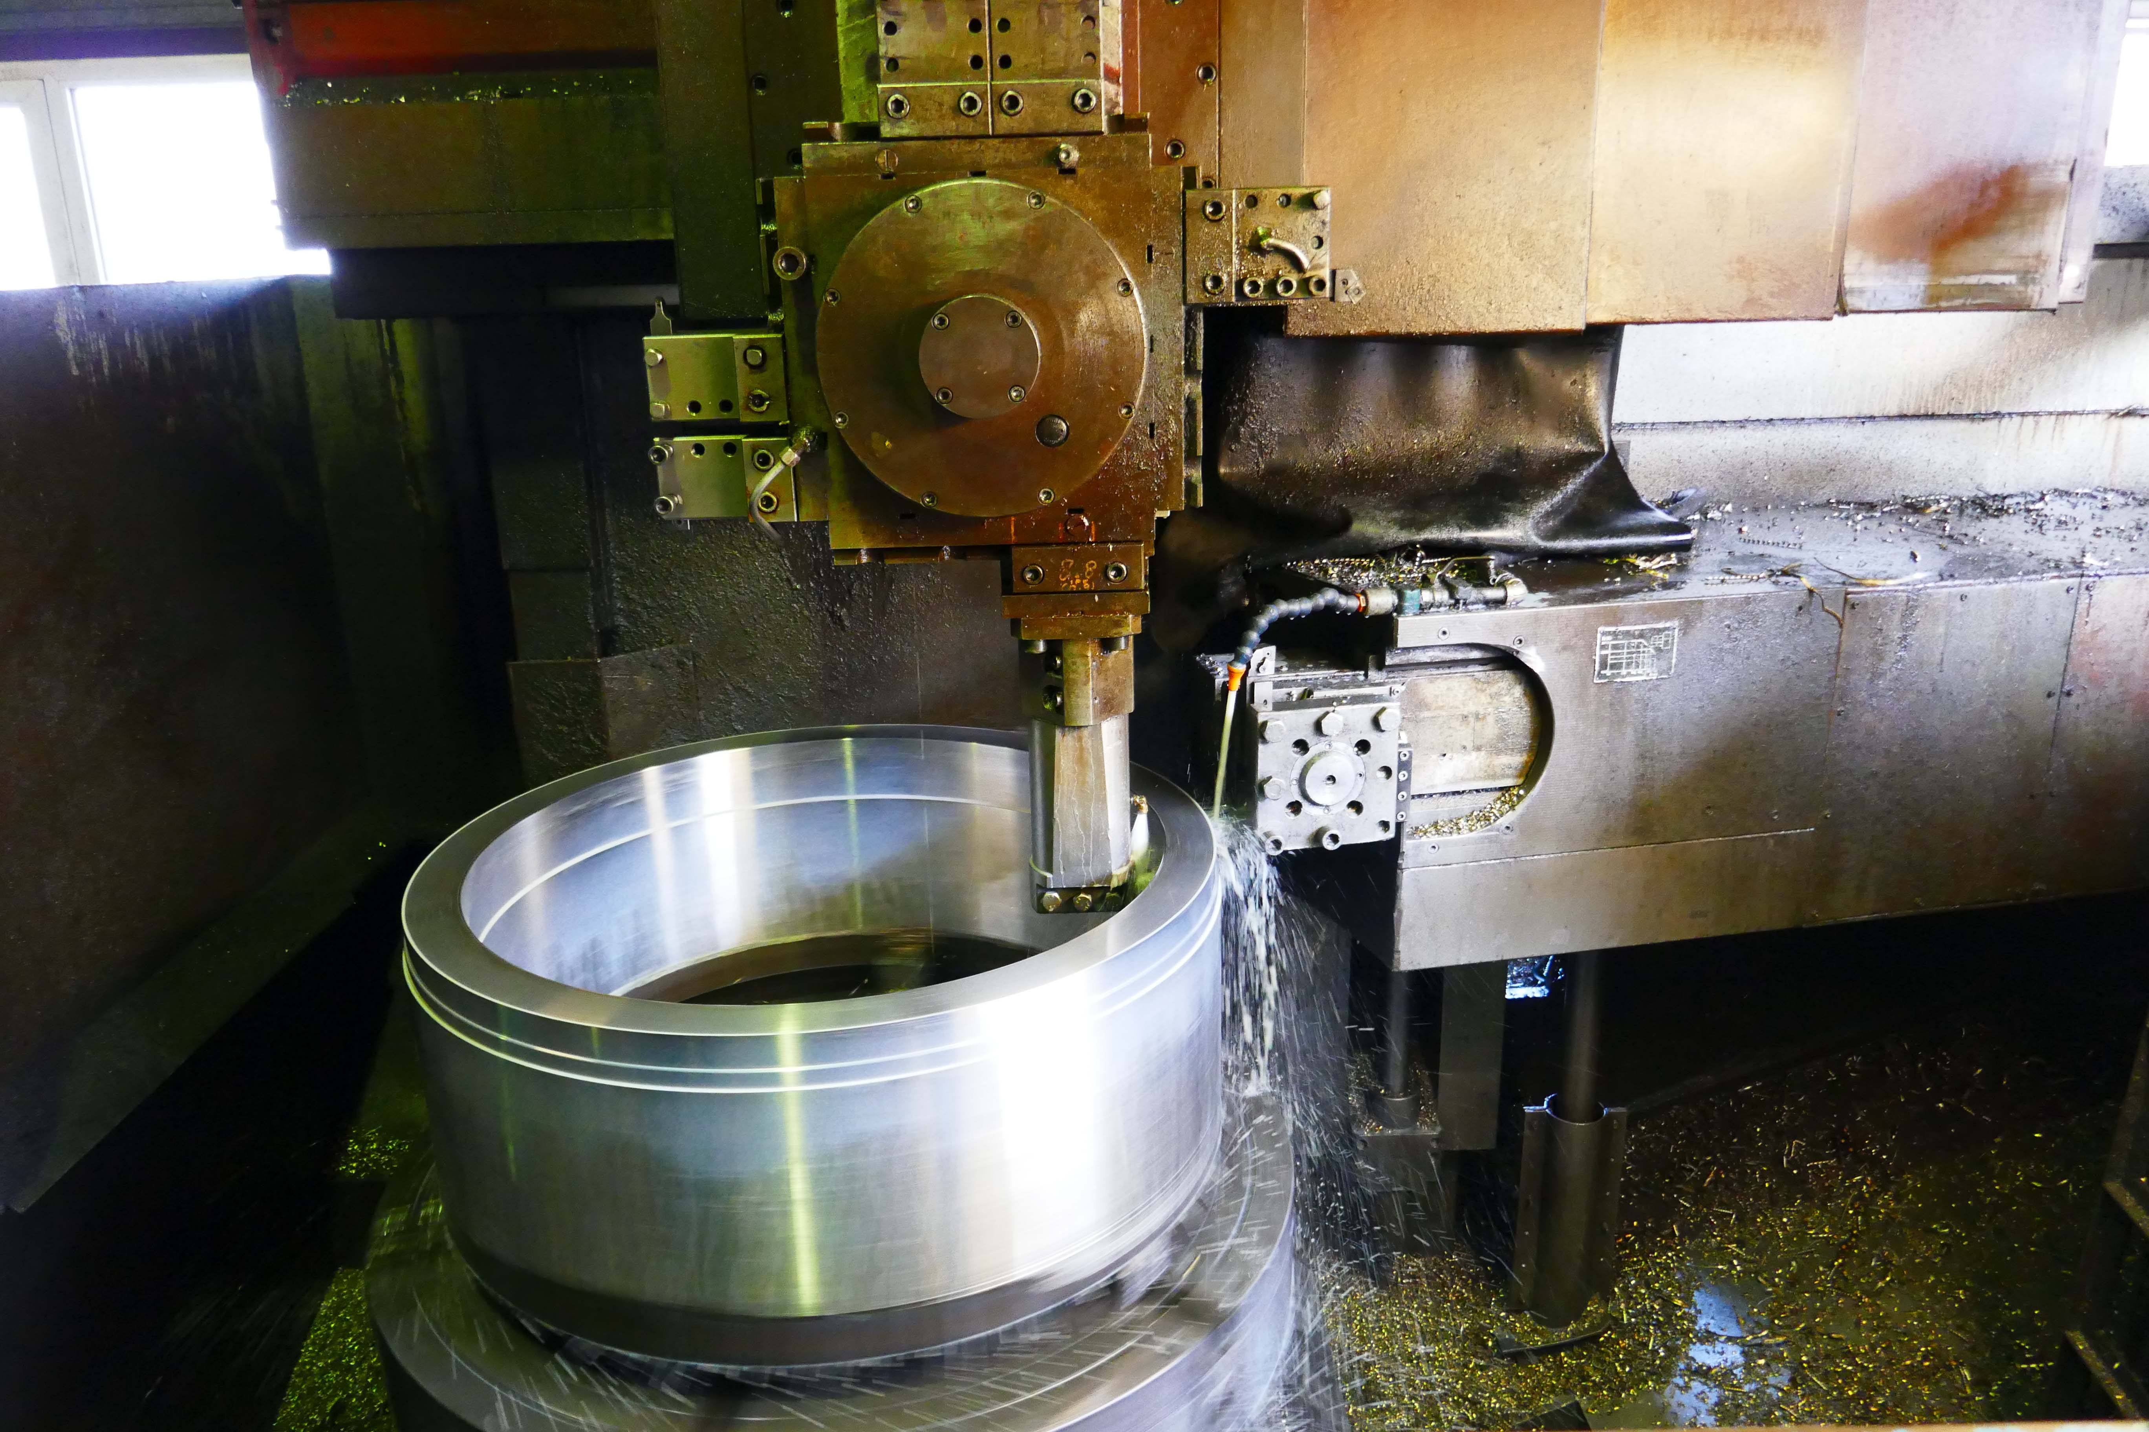
- Ram stroke : 1.000
- Work load : 8.000
- Max. tool shank : 40 x 40

- Table speed range 1 : 2,5 - 60
- Table speed range 2 : 6 – 250

- Rapid feed rate : 8.000 mm/Min
- Feed rate : 4.000 mm/Min
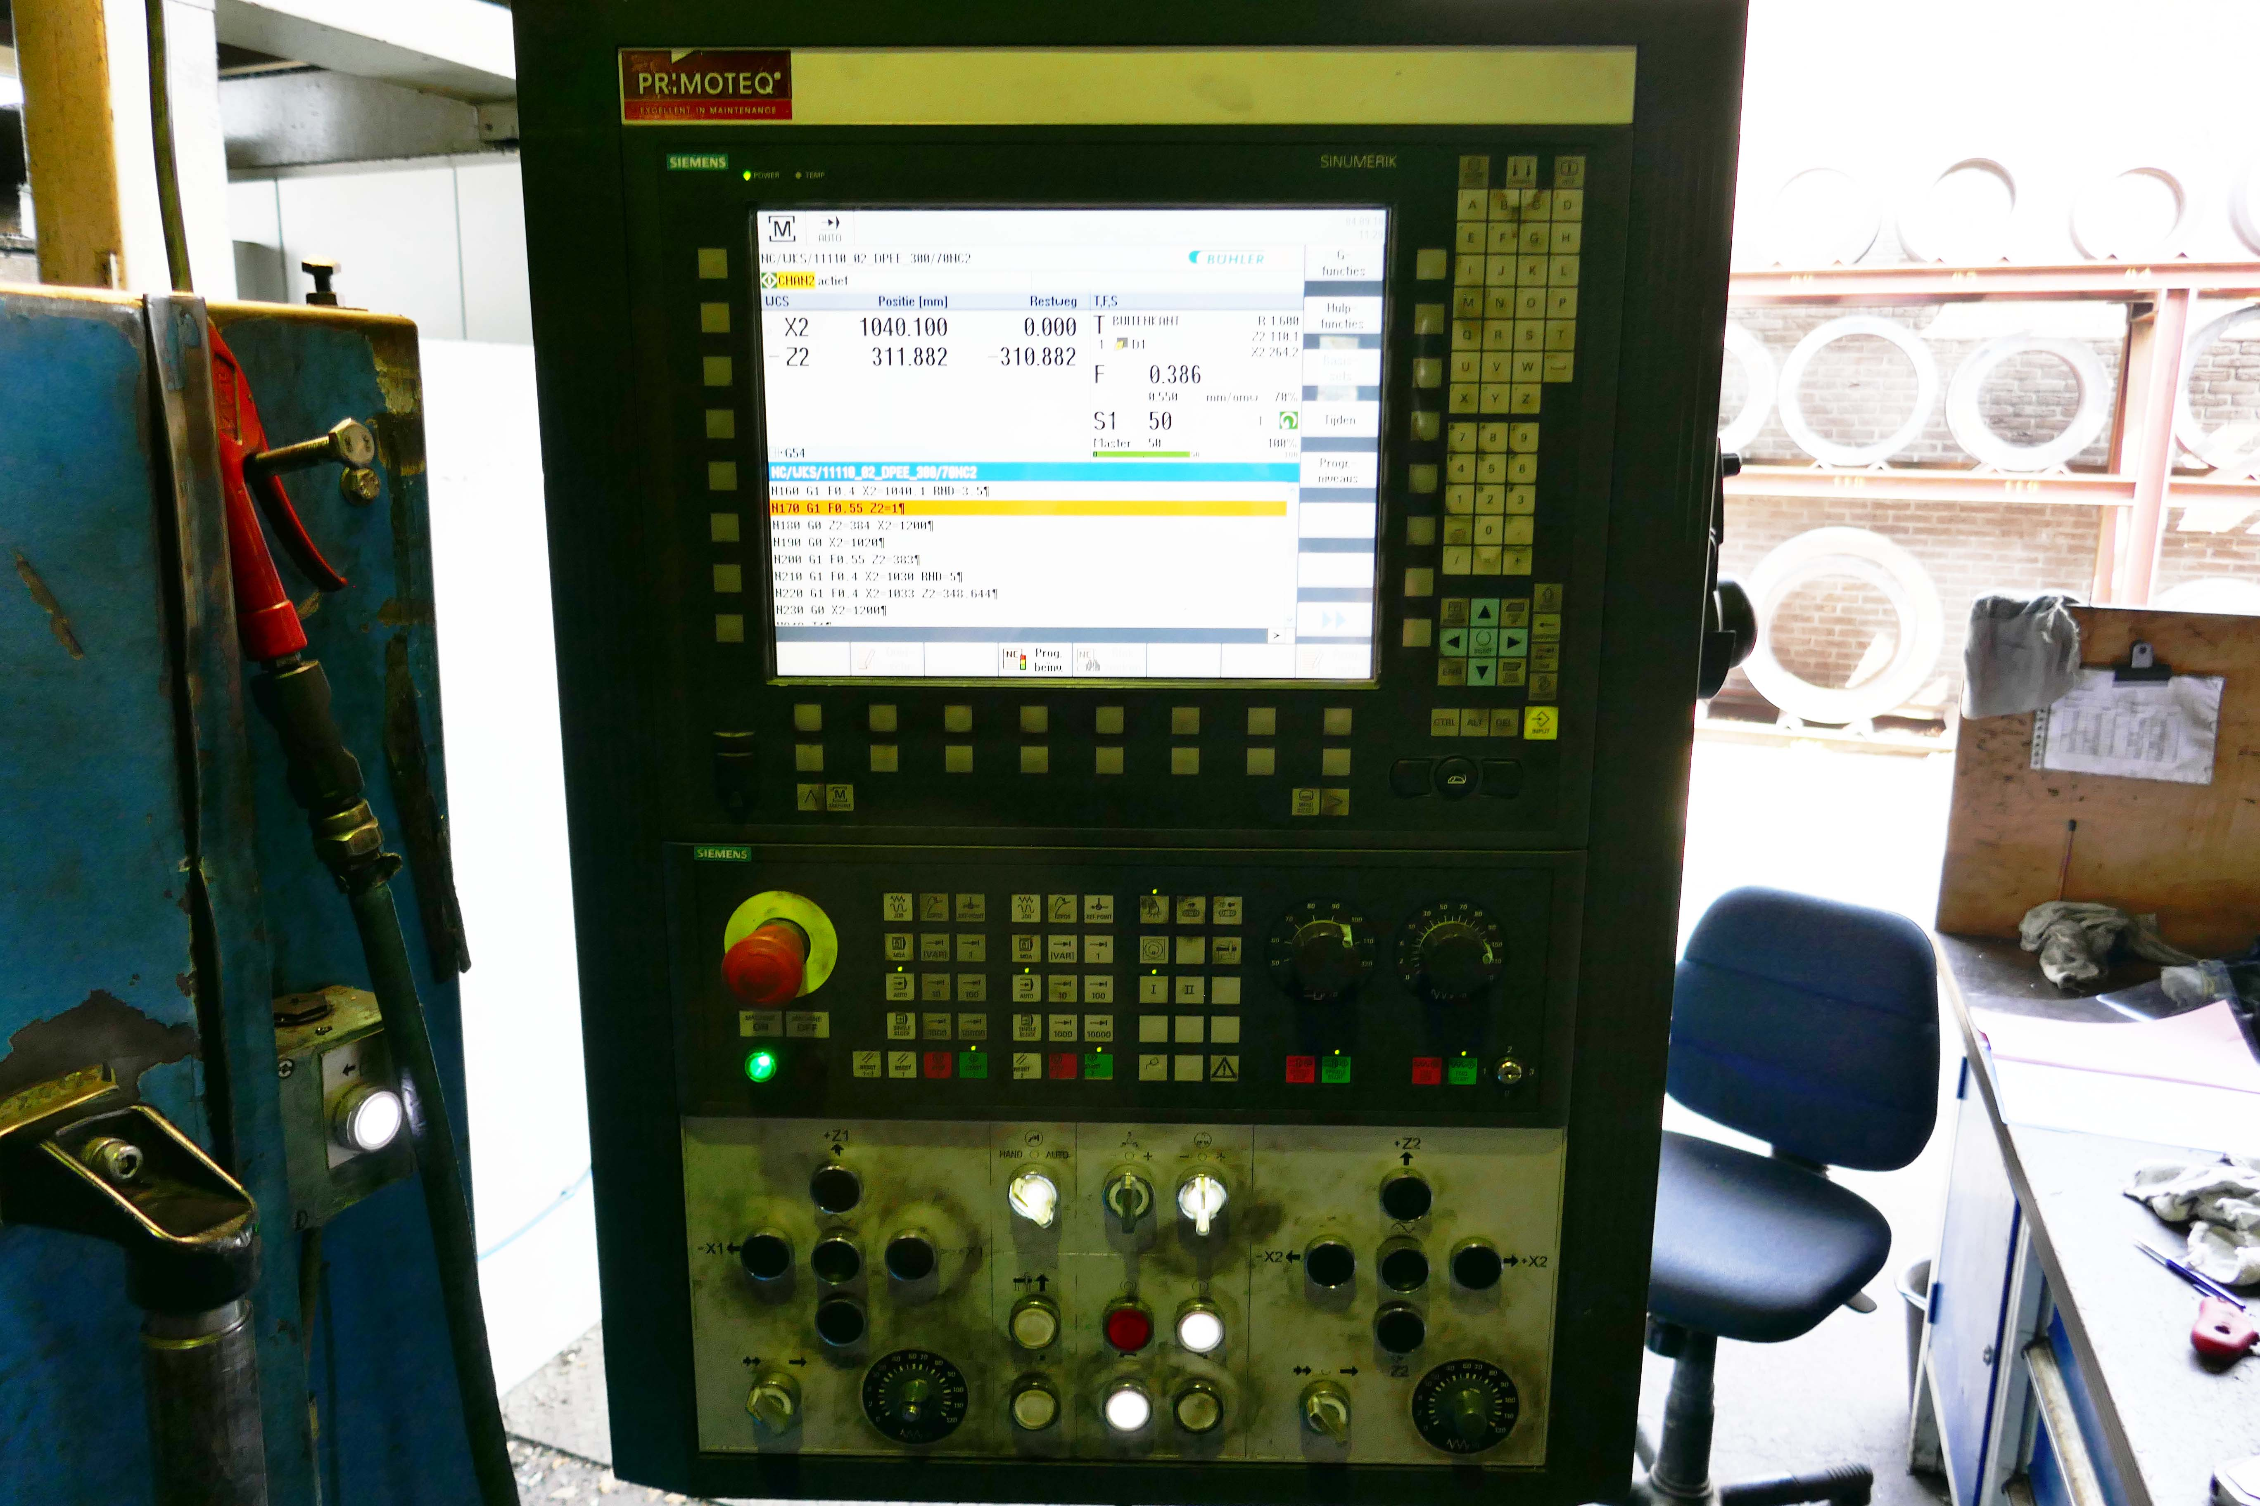
- CNC Siemens 840D in 2 Axis
- Rebuild in 2014 by Primoteq

- Dimensions
- Length : 5.000
- Width : 5.875
- Height : 5.575
- Weight : 25.200
- Power : 40 kW

Note: The above information has been obtained to the best of our ability and belief from, and from the manufacturers where possible. It is given in good faith but its accuracy can not be guaranteed. Accordingly, it will not form a representation or constitute contractual terms. We advise you to check any vital details

